Api, express and Nodejs Application

Api file Url : <http://tiny.cc/ApiFile>

1. New Customer Insertion

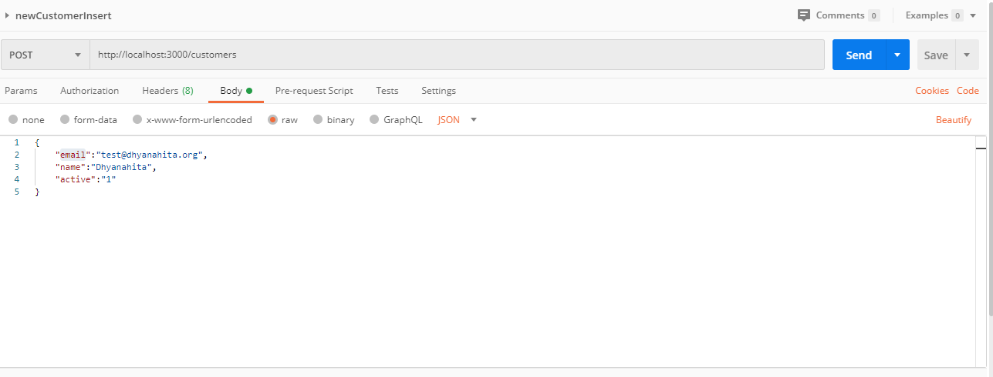

1. Get All Customers details

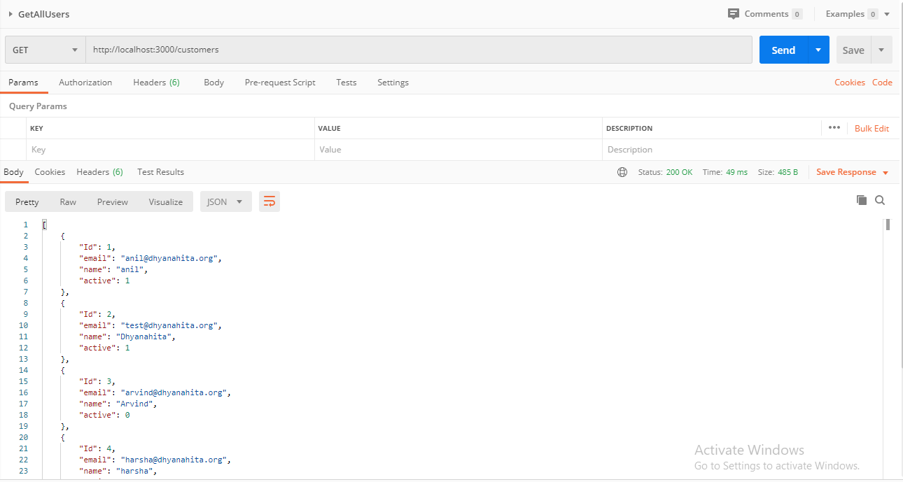

1. Get Single User Details

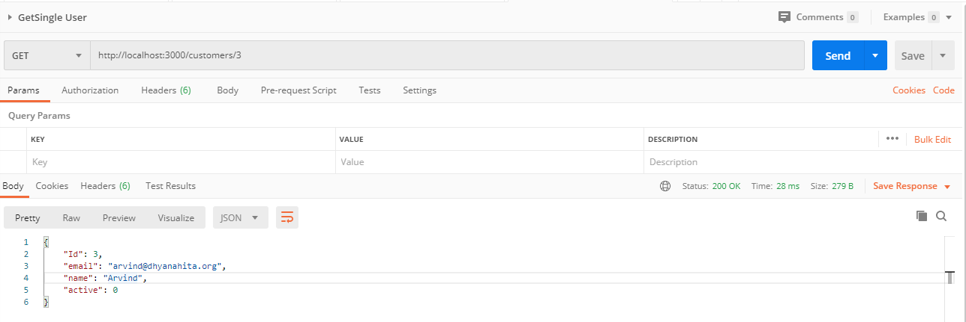

1. Delete a Single User

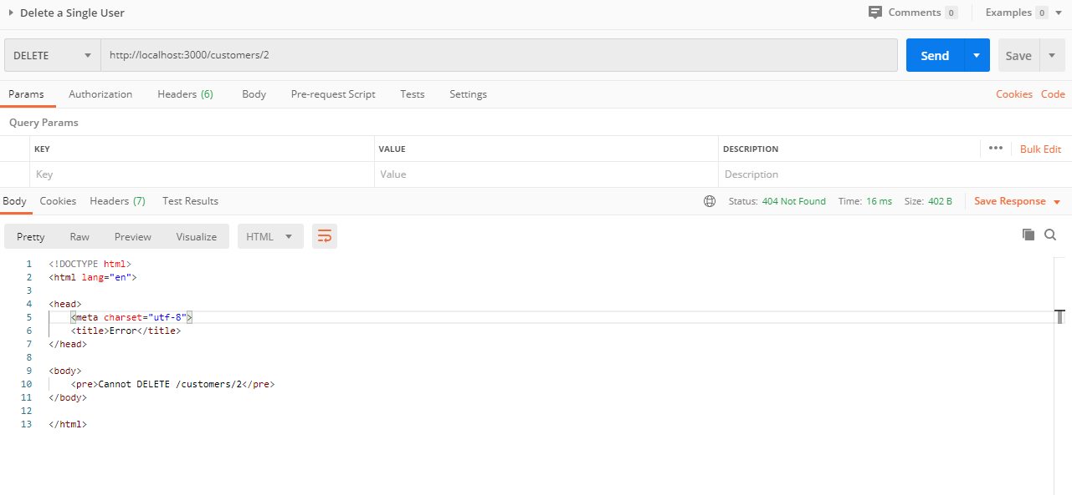

1. Delete all the users

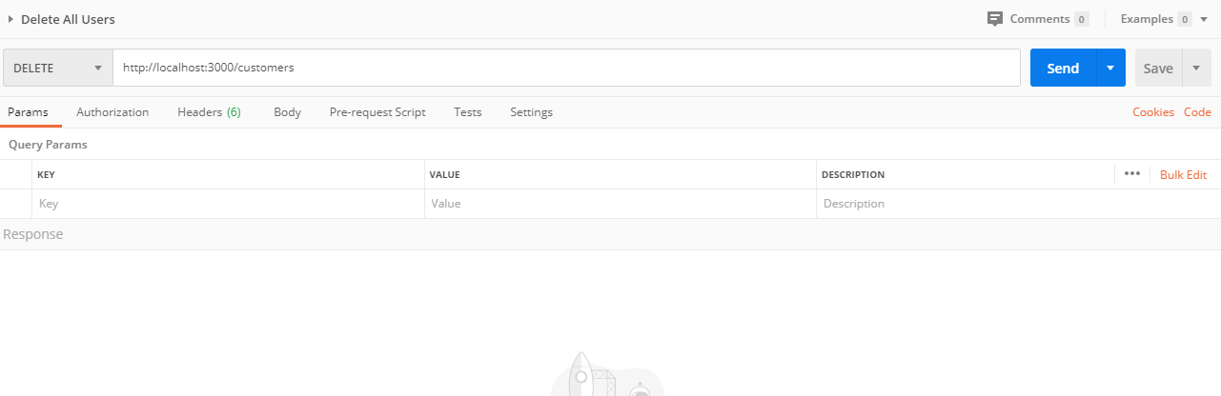

1. Update User

